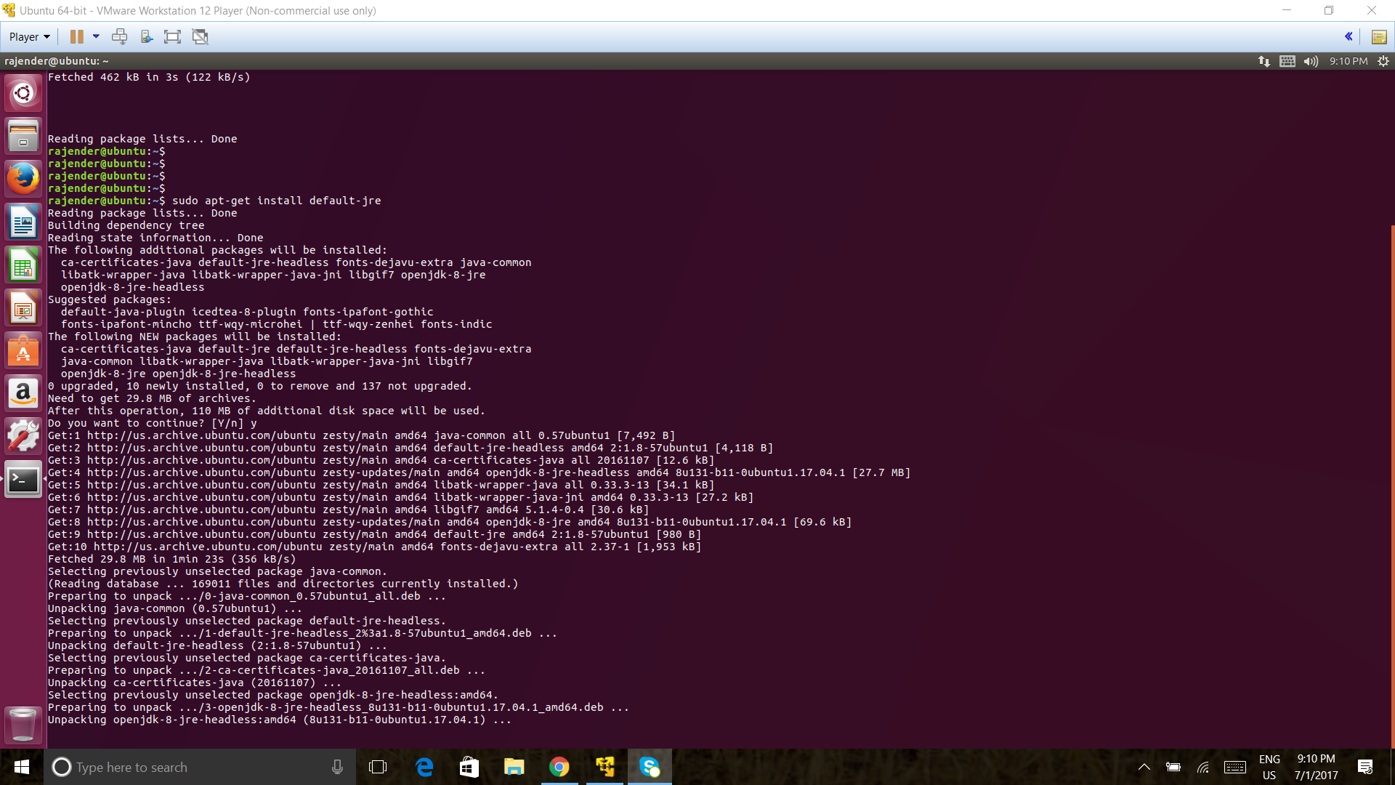

RAJENDER KETHIPALLI HW 2

UPDATE PACKAGES AND JAVA INSTALLATION

sudo apt-get install jenkins
Reading package lists... Done
Building dependency tree
Reading state information... Done
The following additional packages will be installed:
daemon net-tools
The following NEW packages will be installed:
daemon jenkins net-tools
0 upgraded, 3 newly installed, 0 to remove and 137 not upgraded.
Need to get 70.5 MB of archives.
After this operation, 71.7 MB of additional disk space will be used.
Do you want to continue? [Y/n] y

JENKINS CODE

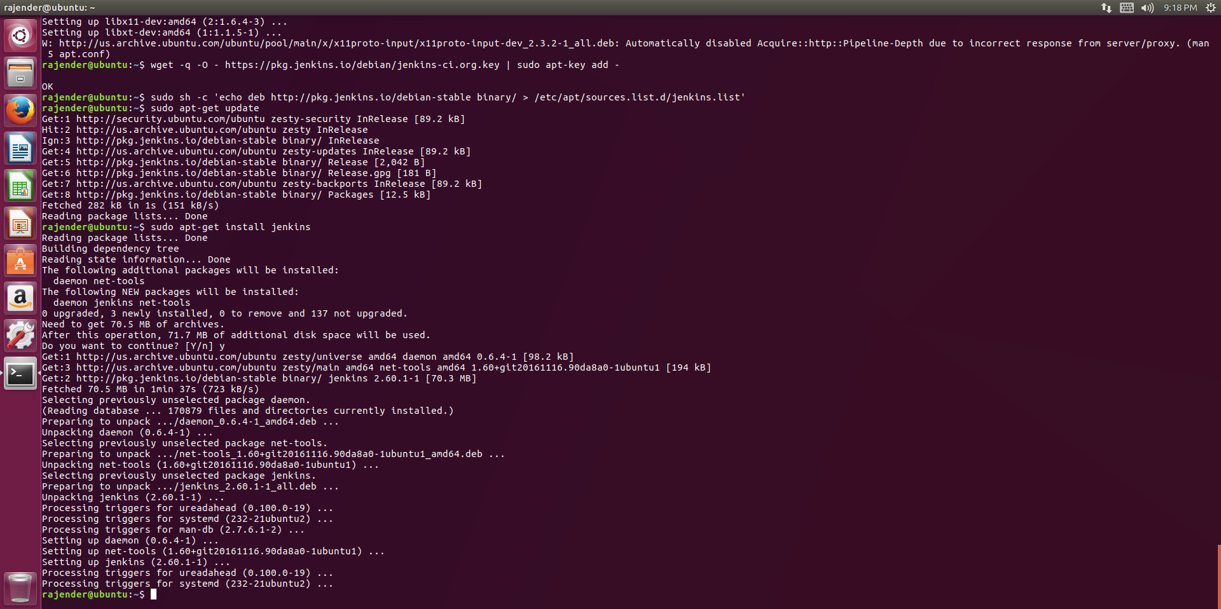
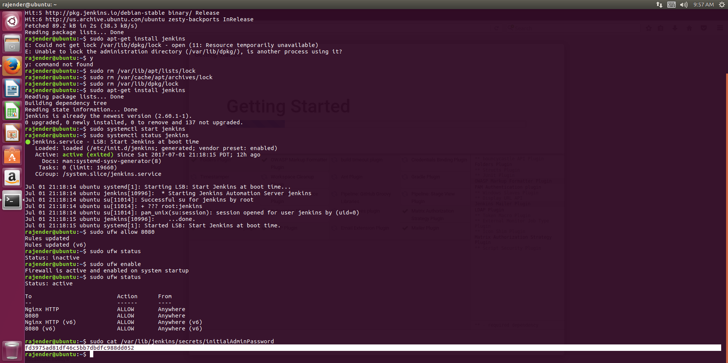
app lock removal to the clean build

firewall setup and status enable

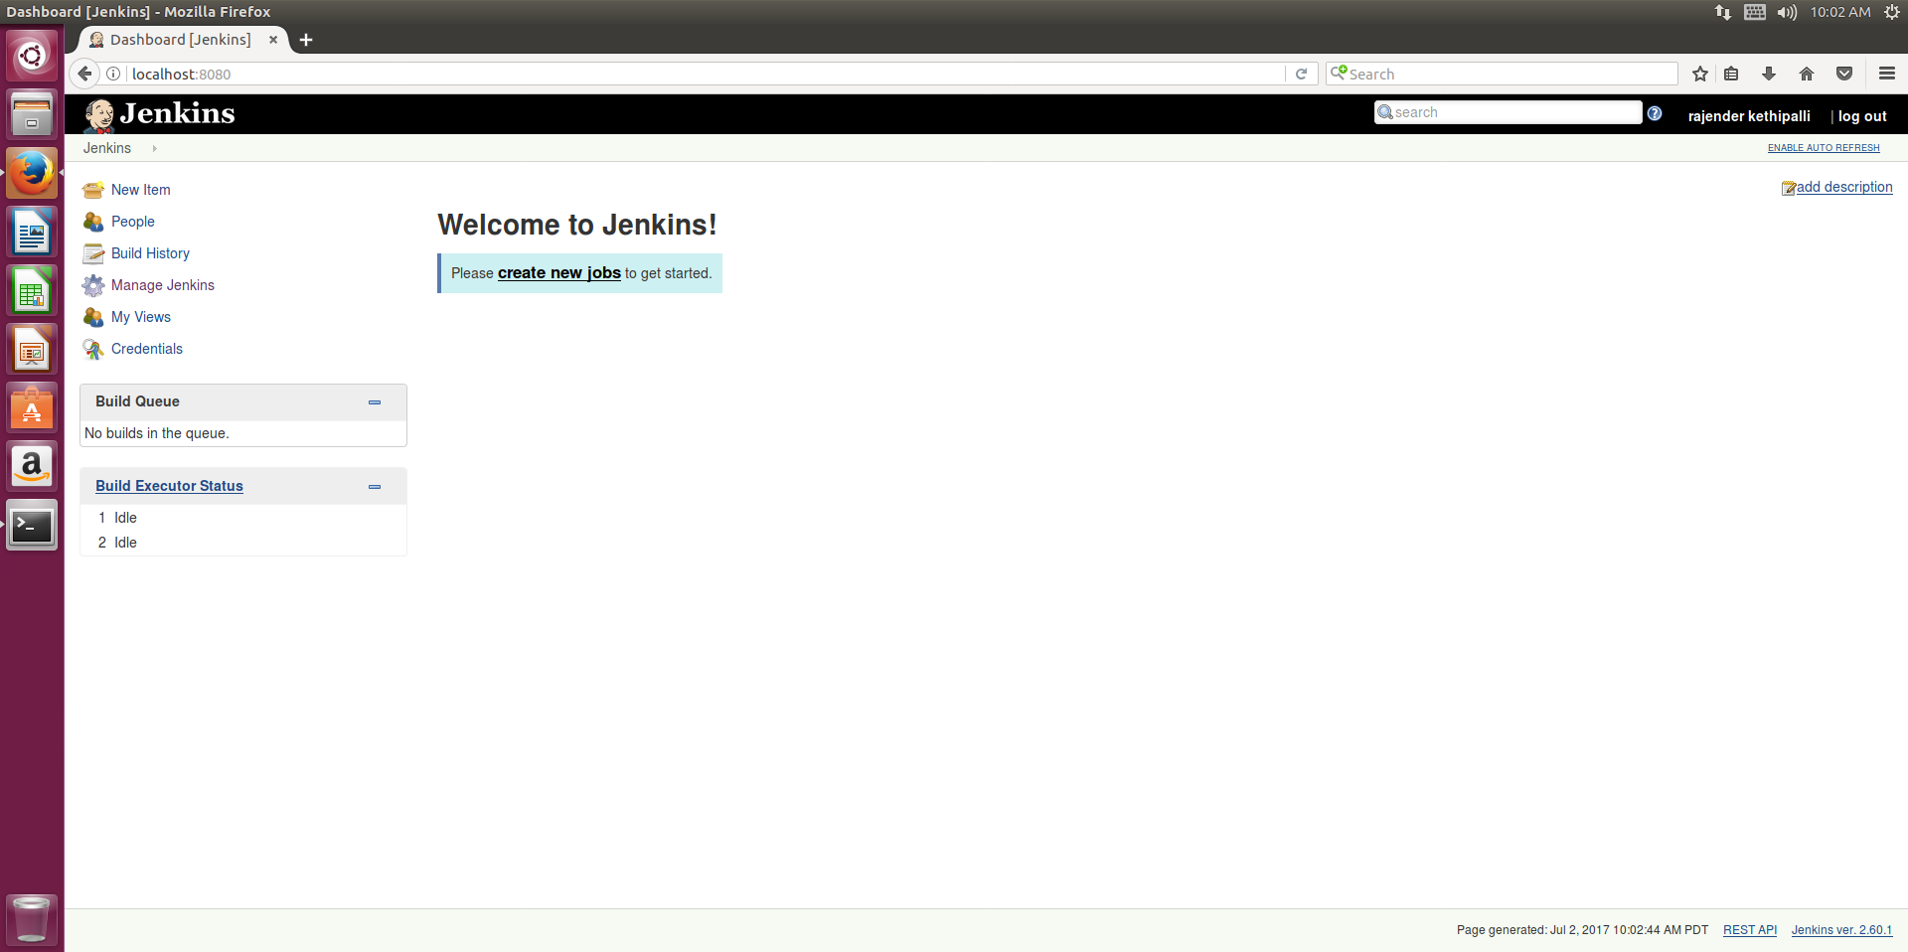
jenkins welcome page

